m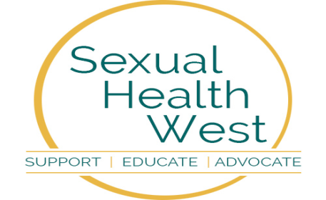

Sexual Health West
Annual Report 2023

Organisation Address (registered office) and contact details:
Sexual Health West
Ozanam House
St Augustine St
Galway
H91 VP3V

Charity No: 11278
Reg No: 228073

Introduction
Sexual Health West (SHW) is a not for profit Non-Governmental Organisation (NGO) limited by guarantee.
Sexual Health West is a West of Ireland based charity working in the area of HIV and sexual health, our offices are located in Galway. Our primary function is to provide support for people living with HIV, we also deliver extensive education programmes and information in relation to HIV and sexual health. We are funded by the HSE, but also receive income through donations and sponsorship. Established in 1987 as Galway AIDS Alliance, in response to the global pandemic of HIV/AIDS, we have always strived to serve our community with care and compassion. Our role has evolved over those years and expanded from that initial group of dedicated volunteers into a professional and committed team.
We aim to encourage the development of openness and honesty around HIV and sexual health issues in Ireland. Sexual Health West is known as a centre for reliable, informed and up-to-date information regarding all aspects of HIV and sexual health. We offer evidence-based skills training and support for people with issues about HIV, sexuality and relationships. Through our education programmes, we look to limit future transmission of the HIV virus and reduce the impact of the negative consequences of sexual activity such as the transmission of STIs (Sexually Transmitted Infections) and the potential for unplanned pregnancies. Our free community based Rapid HIV testing service encourages easier access to HIV testing services with the aim of reducing onward transmission of the virus whilst also linking people with treatment and support services earlier if necessary.

Chairperson’s Note

Dear Friends,
HSE reports that the rates of viruses that are sexually transmitted such as Chlamydia trachomatis, Gonorrhoea, Herpes simplex (genital) and HIV these are now are increasing. These infections can be treated but if left untreated they can lead to serious health problems. This is where Sexual Health West (SHW) comes in!
SHW offer, with no charge, condoms for those who wish to acquire them. SHW also offers testing for those who feel they may have contracted one of the STIs (Sexually Transmitted Infections). If there is a positive reading to a person’s test, we open up the way to refer them to the relevant HSE clinic. Also, importantly, we have given a priority through our WISER programme to educating our young people in schools and colleges concerning a healthy and safe sex life. We stress the absolute of Consent in sexual relations with another person, we give emotional space to listen and to discuss gender issues.
Our CEO attends various conferences within Ireland, within the EU and the UK to share knowledge and to learn best practice from other nations. We have an expert and highly informed team of seven members who value accountability and transparency at all levels of the organisation. They take seriously issues of confidentiality and ensure we are ethically compliant with best ethical practice. Our Board of Trustees are proud of the work the staff do; the combined skills they bring to that work, and particularly we appreciate the empathy and compassion they display in all sorts of situations.
Leading SHW is our CEO. We are very grateful for the enormous amount of work he does; his skilled leadership at so many levels including his attendance at national and international conferences where he is adept at assimilating new insights and sharing them with his team. His ability to secure grants and donations is as impressive as it is welcome. He runs a very effective team and also keeps the Board well informed on a monthly basis.

The Board of seven Trustees of Sexual Health West (SHW)has a legal and moral responsibility for the correct running of the SHW as a Charity. The Board also ensures its policies are ethical and accountable, its governance is in order and, with the HSE, its strategy going forward is clear. The work of our trustees is exceedingly valuable especially in ensuring our accounts are in good order and annually audited. As Chairperson I am so fortunate in having such an amazing cohort of Trustees. I value their attendances, their informed opinions, their listening skills and their advice.
To our staff, our Board members, our stakeholders, to our many service users and to all who have become part of the family of SHW both past and present a VERY BIG THANK YOU for what you do and what you are.
We shall continue onwards with care. Rather we shall strive, with aspiration and venturesomeness to help build a healthier society. And together, we shall do it with joy.

Patrick L. Towers (Chairperson)

CEO's Foreword
I am delighted to present the Sexual Health West Annual Report for 2023. This report is an opportunity to reflect on the work undertaken by Sexual Health West over the past year and it also gives an insight into the many services that we continue to provide and develop. In this report, you will find details of the various activities and initiatives that Sexual Health West has undertaken over 2023, including some of the key achievements, challenges, and contributions made throughout the year.
The HSE Health Protection Surveillance Centre (HSPC) data demonstrates that there continues to be an alarming increase in the number of newly diagnosed cases of HIV and STIs. The last annual figures that we have are for 2022, and these indicate that Ireland had the highest rate of HIV diagnoses in western Europe last year, according to the European Centre for Disease Control and the World Health Organisation. At 17.5 per 100,000 people, the Irish rate of HIV diagnosis was over three times higher than the European average.
In 2022, there were 884 HIV notifications in Ireland, this represents a 68% increase in 2022 compared to pre-pandemic year 2019. There had been a steady upward trend in HIV rates between 2015 and 2019 and lower rates in 2020 and 2021 due to COVID-19 pandemic, however 2022 figures indicate a 68% increase.
We have more up to date 2023 figures for rates of STIs in Ireland, and these indicate that the STI notification rate in 2023 increased by 30.7% compared to 2022, as Ireland like other European countries is experiencing an increase in STIs. Overall STI rate in young people aged 15-24 years increased by 38% compared to 2022 figures. It is important to note that the HSE Free Home STI Testing service introduced nationwide in 2022 has increased capacity for STI testing and diagnosis in Ireland and has led to better case ascertainment.
The west of Ireland continues to be impacted with the arrival of Ukrainian Refugees since the Russian invasion early in 2022, with over 100,000 Ukrainians newly resident in Ireland since the conflict began. Tens of thousands of thousands are resident in west of Ireland, and we look to support them with advice and information relevant to their sexual health needs. Sexual Health West continues to offer a range of essential services as we look forward to supporting the implementation of the next HSE National Sexual Health Strategy in 2024.
I want to thank all who we work with and support – individuals, schools, colleges, community groups and organisations for their continued support. I also thank our excellent staff team for their hard work and dedication over the past year. Your commitment and enthusiasm have made Sexual Health West’s achievements possible.

We remain hopeful for a brighter year ahead, particularly with new staff appointed in 2024 increasing our capacity to deliver exceptional services across the region.

Finally, I express my sincere appreciation to the board of SHW for support and guidance to the organisation and to myself.
Joe McDonagh, CEO - Sexual Health West

MISSON STATEMENT & OBJECTIVES

Mission Statement

Sexual Health West is a charity which provides a safe and welcoming environment for everyone with whom it works. Our office is based in Galway.

Our Mission is to:

- Deliver the highest quality care and support to people living with HIV/AIDS or STIs.

- Empower those living with HIV to optimise their health and well-being.

- Raise awareness around HIV/AIDS, and STI issues and work to eradicate stigma and discrimination.

- Promote positive sexual health without prejudice or discrimination.

Objectives

- Deliver the highest quality care and support to people living with HIV/AIDS or STIs

Support

- To offer emotional/psychological support to people living with HIV/AIDS or STIs according to their stated needs and to the ability of Sexual Health West to deliver those supports.

- Support may be by telephone, email, or by face-to-face meetings with the coordinator.

- Telephone Helpline support may be offered by other Sexual Health West staff.

- Support groups or ‘buddying’ by similarly affected people may be offered.

- If deeper psychological support is needed a person may be referred to a Psychotherapist or more appropriate counselling services.

- Support may also be offered to a person who makes contact who is experiencing a sexual health crisis or problem.

Care

- Offer practical assistance to people living with HIV/AIDS or STIs e.g. in finding suitable accommodation or in obtaining social welfare benefits.

- May provide complementary/holistic therapies for the physical/holistic wellbeing of the person affected.

To empower those living with HIV to optimise their health and wellbeing

- Workshops on different aspects of personal development facilitated by experienced practitioners are offered from time-to-time to people living with HIV who use the Sexual Health West Care and Support services.

- Workshop topics will include areas such as:

Improving self-esteem
Fighting against stigma
Campaigning for the best possible support services and treatments

Raise awareness

- We raise public awareness of HIV/AIDS, STIs and sexual health through awareness campaigns, provision of information material, use of various media, seminars, publication of a newsletter and public events.

- Provide a confidential Helpline / Information Service on HIV/AIDS, STIs and sexual health matters.

- Ongoing use of technology to provide information on HIV/AIDS, STIs and sexual health by maintaining up to date information on our website www.sexualhealthwest.ie the WISER website www.bewiser.ie and the Sexual Health App.

- Draft and publish leaflets, posters, brochures and booklets on sexual health matters for information and distribution to health clinics, doctor’s surgeries, seminars, conferences, colleges etc.

Promote positive sexual health

- We will enhance sexual well-being by the provision of responsive and innovative training programmes to schools, community groups, youth organisations etc and work in conjunction with state agencies to provide these programmes where appropriate.

- We will provide outreach programmes for at-risk groups i.e. LGBT+ community, asylum seekers, prisoners and many others in the form of education, support, advice and provision of free condoms.

- We will provide outreach services to young people who are potentially at risk and who are not in contact with other services.

- We will work with the Western Region Drugs & Alcohol Task Force [WRDATF] to deliver holistic educational programmes which link sexual health with drug and alcohol abuse.

Best Practice

- Participate in research on sexual health, disease prevention and best care
practice.

- Participate in national/local meetings and networks/associations in order to
develop and maintain models of practice.

- Work with HSE and community groups in the development and delivery of “Train the Trainers” programmes to schools, community groups etc.

Report on Activities 2023
In addition to education and prevention initiatives, throughout 2023 we have continued to provide professional and responsive care and support services to anyone who is living with HIV and other STIs, as well as for those who have worries about their sexual health.
We do this by:
- running awareness campaigns and providing information to the general public through our media channels
- providing targeted education and outreach through partnerships with community organisations and programmes
- responding to specific queries directed to us from individuals through email, phone and social media channels
- providing a comprehensive condom service that includes information provision on good sexual health
- maintaining a close relationship with our hospital colleagues in the GUM clinic
- being available at short notice and quickly acting on new referrals when people are going through crisis periods
- supporting families of those affected by HIV & STIs
- having contact with our client group through a regular newsletter
- meeting up with clients face to face, online and providing phone support
- organising gatherings and events where possible for people to meet in groups and peer support
- ensuring other opportunities for peer support through national events and initiatives

Support Services - People Living with HIV & Sexual Health Support
Support Service Summary 2023
The full report from the Health Protection Surveillance Centre (HSPC) regarding HIV for year ending 2023 is not yet complete, however the latest figures and reports available for 2023 indicate a further 5.6% increase in the numbers of new diagnoses of HIV in Ireland (compared to figures for 2022). The numbers of new HIV diagnoses notified in Ireland in 2023 was the highest rate ever reported in Ireland.
Additionally, the numbers of new Sexually Transmitted Infections continued to rise in 2023, with a 25% increase in new notifications of Chlamydia, 68% increase in Gonorrhoea, 5% increase in Herpes and 9% increase in new notifications of Syphilis.
Over 2023 we have continued to provide support to our current client group as well as furthering our support to new clients who are living with HIV and other STIs or worries about their sexual health. We have also continued to reach out and respond to enquiries from other agencies, organisations and the general public with sexual health information and support.
We do this by:
- meeting up with our client group face to face, online and providing phone support
- supporting families and partners of those affected by HIV & STIs
- organising gatherings and events where possible for people to meet in groups and peer support
- ensuring other opportunities for peer support through national events and initiatives
- responding to specific queries directed to us from individuals through email, phone and social media channels
- quickly acting on new referrals and being available at short notice when people are going through crisis periods
- running awareness campaigns and providing information to the general public through our media channels
- providing targeted education and outreach through partnerships with community organisations and programmes
- providing a comprehensive condom service that includes information provision on good sexual health
- maintaining a close relationship with our hospital colleagues in the GUM clinic
- having contact with our client group through a regular newsletter
- promoting our book Sex Educated to a wide audience
- creating regular social media information posts branded as “Factual Friday” to educate and inform the public on sexual health topics

Over 2023, our services included having a presence for patients linked to University Hospital Galway, face to face meetings and support, the World AIDS Day Concert and events, attending community open days, participating and networking with community forums and meetings, and offering HIV & Syphilis testing in multiple community locations. Through these events, our presence in the community has increased significantly
Most of our client group are referred through the GUM clinic and people also contact us through email, social media and website and they are responded to promptly by a member of our team. Client support is offered face to face as a priority, with other options being phone, WhatsApp and zoom. Our coordinator met clients in Galway and continued to offer outreach in County Galway, County Mayo and County Roscommon & County Sligo. We continue to develop our partnerships with linked ogranisations locally including Amach, Outwest, community centres and family resource centres. partnership with them as an organisation.

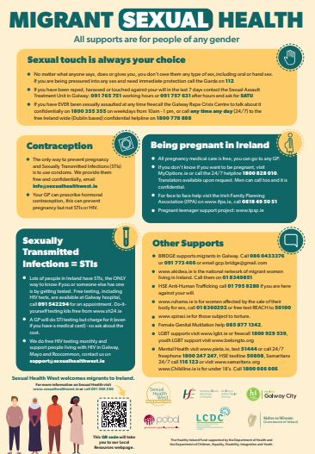
The Galway Sexual Health Forum is still flourishing meeting regularly it proves useful both as a networking and an education resource for its members. SHW are part of the Tusla Family Support Network, a Parent Support CYPSC subgroup, the Galway City Community Network, and the SHW representative member on the Gay Health Network. We have also strengthened our relationship with Amach in Galway by developing a regular HIV & Syphilis testing sessions in their space.

Over the course of 2023 we continued to meet with migrant groups and provide services and resources as possible in response to their needs. As well as the Migrant Health information, the Sexual Health West website has been kept up to date with current information and resources in this region and further afield.

WISER (West of Ireland Sexuality Education Resource)
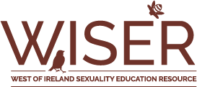

The WISER (West of Ireland Sexuality Education Resource) education team are part of Sexual Health West. Staff members are highly trained, experienced and dedicated to delivering Relationships and Sexuality Education. Our programme(s) provide evidence-based, factual, non-judgmental sexual health information on topics such as:
- Consent and Relationships
- Contraception, Protection and STI’s
- Anatomy, Reproduction, Sex and Pleasure
- Gender Identity and Sexuality
- Nudes, Pornography and IBSA (Image Based Sexual Abuse)
- Support Services for young people

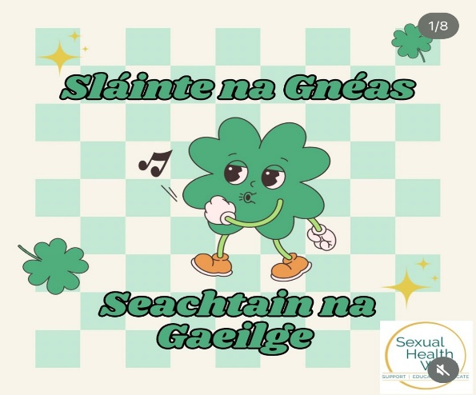
As WISER educators, we continuously update our content and facilitation style to ensure we are delivering comprehensive, factual, progressive, inclusive, empowering, age-appropriate, non-judgemental and sex-positive Relationship and Sexuality Education.

Comprehensive sex education programs have demonstrated the reduction rates of early sexual activity, sexual risk behaviours, STIs, and adolescent pregnancy.

Many literature reviews have indicated that comprehensive sex education promotes healthy sexual behaviours:
- Reduced sexual activity.
- Reduced number of sexual partners.
- Reduced frequency of unprotected sex.
- Increased condom use.
- Increased contraceptive use.
However, comprehensive sex education curriculum such as WISER, goes beyond risk-reduction, by covering a broader range of content that supports social-emotional learning, positive communication skills, and development of healthy relationships.

Secondary Schools: January 2023-December 2023
We continued to deliver to a number of our regular schools within Galway city. Within the county, we travelled to: Athenry, Clifden and Oranmore.
Our regular Mayo schools had both Junior and Senior Cycle Programmes in some, and areas covered included: Castlebar, Swinford, Ballina, Louisburgh and Claremorris.

Evaluation of the WISER Secondary School Programme (2022-2023)

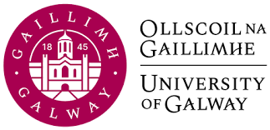
Discussions began in 2022 regarding the evaluation of the WISER programme, it had been in the pipeline for a number of years. The evaluation was carried out by University of Galway Health Promotion Department, and the document was finalised in August 2023. There was considerable work involved by SHW; providing relevant information from our student evaluations, attending in-depth interviews and providing written documentation on various aspects of the programme. Overall it was a very positive evaluation, recommendations for improvement were provided and the WISER coordinator will implement these.

The evaluation emphasized the importance of regular team contact, and a well-trained and cohesive team. It also revealed the need for a comprehensive training manual or toolkit to support new trainers and ensure program sustainability. It also highlighted the programme’s adaptability and dedication to evolving the curricula based on learners' needs and transferring organisational expertise to new personnel.

The data collected from workshop feedback sheets from 2017 to 2021 provided an overview of participant demographics and workshop scope. The feedback was gathered from 2,437 students in 32 schools, with a diverse mix of age groups and gender distribution. Feedback from students indicates high levels of satisfaction and improved understanding of sexual health, with greater impact observed among younger students and girls.

The evaluation study recognizes WISER's strengths in several areas while making important recommendations for improvement to ensure programme longevity and reducing organisational dependency on key individuals, promoting collaboration and knowledge transfer. Expanding the programme team to cover primary schools and providing training resources for staff and teachers would enhance its reach and effectiveness. Specific needs of students with learning difficulties should be addressed, fostering inclusivity and continuous professional development. Harnessing youth participation approaches, establishing a safe space for essential services, and articulating a Theory of Change framework for evaluation and improvement are essential steps to enhance the program's impact and sustainability.

A Little WISER (Primary School Programme) April – May 2023
Our Little WISER programme began delivery in May, with parenting events running from late March into April. We continued the delivery of parent’s/guardians information evenings online, due to the success from previous years. All primary school programmes were received very positively from young people, and all other stakeholders. The programme continues to be sought by other schools and this is an area that could expand our reach. Consideration would need to be taken here regarding the amount time and resources delivery takes before taking on more schools.

Student Placements within Sexual Health West
We facilitated one Health Promotion Student from Oct-April. They attended some school sessions for both facilitation skills and the experience of seeing our sexual health programmes in action.

The placement went well but there were restrictions on the student’s availability to attend schools. Going forward we plan that students will have a sexual health project in place to ensure they get the most from their time with us.
We continue to work with NUIG annually in facilitating placements from the Health Promotion Department and the collaboration works very well.

Community based Sexual Health Works
Renmore Barracks:
Provided new recruits a once off session regarding STI’s, Testing, Contraception and Protection and Support Services. It was very well received.

ISPCC
A request was made to support staff from the ISPCC who work with young people. A two-hour workshop was tailor made for the group after consultation with management. It was specifically for the organisations Childline therapeutic support workers that work individually with children and young people with emotional and behavioural difficulties. It went very well great feedback from the management.

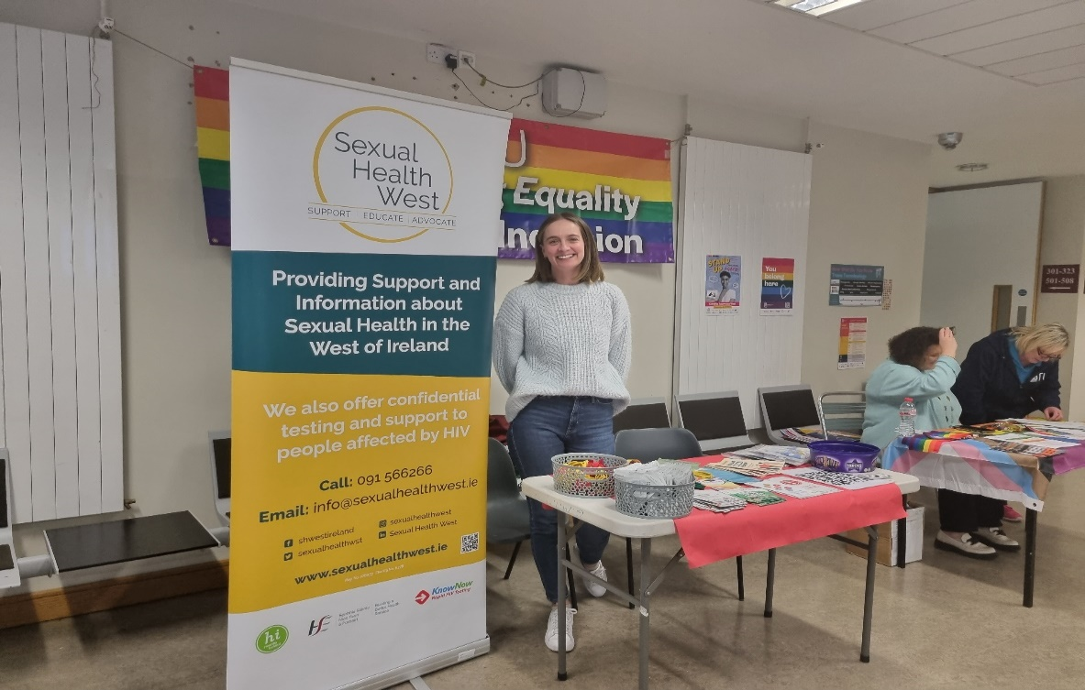

Outreach Session with Denise McAlister

GRCC
The Galway Rape Crisis Centre had made contact regarding delivery to their staff and volunteers. They specifically requested an update on needs regarding young people and sexual health. A presentation was put together by one of the education team for sessions. The feedback received was excellent from both participants and management.

National Learning Network
We continue to work with the NLN providing a number of sessions throughout the year for their service users. We now work with both the new comers to the centre and the transition year group.
We have spoken to staff about the importance of information being reinforced during everyday situations and have provided support where deemed necessary. This is an area that needs to be looked at in the future and if there was scope within our own organisation to provide training for staff within the disability sector.

Amach
A workshop was designed for the LGBT+ community on Menopause. A request had been made by Amach and it was put together after some consultation with the manager. Many issues had been raised regarding access to information, Dr’s not equipped with relevant information and the lack of discussion in general within the community.

WRDATF
A collaborative piece of work was done with the Western Regional Drugs and Alcohol Taskforce. The WISER coordinator provided a presentation with a voiceover to be shown in schools regarding consent and young people going on nights out. The piece was to be shown in schools throughout

Galway, Mayo and Roscommon as part of the WRDTF ongoing work and would also highlight and promote WISER’s Sexual Health Programmes within schools we are not in.

Youthreach Centres
Delivered our Youthreach RSE programme in a number of centres throughout Galway city and County Galway.

Dochas
Continued our delivery with clients in Dochas with a particular focus on relationships and consent as requested by staff

Other areas of work and engagement
NCCA: attendance at round-table consultation on Senior Cycle SPHE, participating and contributing to the ongoing discussion regarding content and delivery

Galway Traveller Movement: The GTM along with the HSE requested meetings regarding a collaborative piece with Sexual Health West. The intention is for us to provide training on female reproductive health in particular for 2024.

INISH Steering Committee
The education coordinator was invited to become a member of the INISH Steering Committee (the new national survey on sexual health). Several meetings will take place annually and we will have the opportunity to be involved in overseeing the survey.

Community Psychology Students Psychology students from UOG visited our office and met with the education coordinator to hear about the work we do. The opportunity is then given to become a volunteer in particular areas of interest, be that HIV testing, observing the education team delivering a sexual health programme or assisting at sexual health promotion events.

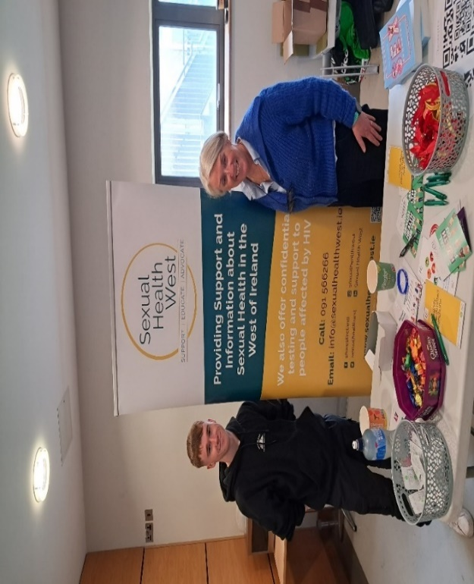
Provision of Sexual Health Information
NUIG Volunteer Fair(s)
Engaging with both staff and students, providing students with information regarding volunteering opportunities and general information on what we do as an organisation.

Men’s and Women’s Health events in the west
Information stands having gender specific information and signposting to relevant services.

SSSTDI event in Dún Laoighaire The event provided a great opportunity to meet specialists in the area, promote our services and our book ‘Sex Educated’.
Jo Mohan at GMIT in Sexual Health Awareness Week

Flirt FM
The WISER team took over the radio show for Irish AIDS Day and spoke about Sexual Health issues highlighting the importance of testing and accessing information. It was a fantastic day and great fun for those of us involved.
WISER Book – ‘Sex Educated’
Sex Educated was published in 2021. We continue to promote the book as a valuable resource for young people themselves and anyone with a young person in their lives, be it parents, relatives or anyone working with young people. Professionals have commented on the publication, holding it in high esteem for both its practicality and breadth of knowledge. We have incorporated illustrations from the publication into our WISER Programme to promote variety and diversity regarding our bodies and bodily functions.
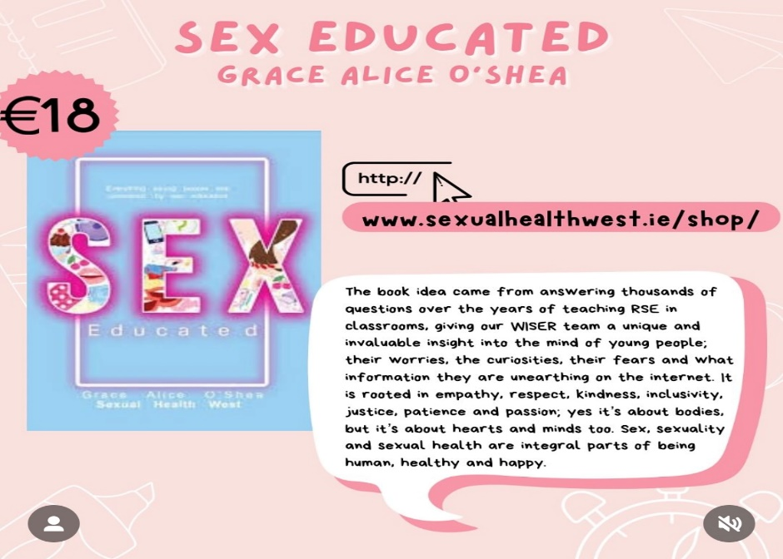

The book can be purchased through the Sexual Health West website: www.sexualhealthwest.ie

The Galway Sexual Health Forum

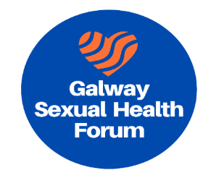
The Galway Sexual Health Forum was formed in 2021 and has continued to meet and ran successfully chaired by Sexual Health West, throughout 2023.
Its main purposes are to facilitate the provision of an excellent and integrated education, support and treatment continuum for all aspects of Sexual Health through the life course and to contribute to the Sexual Health Strategy and policies.
During 2023, we had a number of outside organisations present information on their services, providing forum members with relevant updates regarding sexual health provision throughout Ireland. Organisations included: GOSSH from Limerick, Debunking the Myths from RCPI in Dublin, AkiDwA based in Dublin and ShOUT in Galway City.

Towards the end of 2023 we asked forum members if they felt the sexual health forum was worth continuing for 2024. The overwhelming answer was yes! It was of huge benefit to help disseminate vital information on each other’s and outside services, discussing relevant areas of research, gathering feedback and sharing experiences.

Summary
Once again it was a busy and very successful year for the WISER team. Delivery can be demanding with strains due to travelling, adverse weather conditions, and a very busy workload during school term. I would like to sincerely thank all members for their continued commitment, passion and drive, to provide such a vital service to our young people.

Drugs and Alcohol and the link to Sexual Health

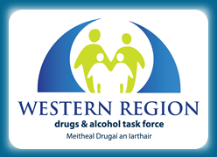
In 2023, most training courses continued to delivered via online platforms. The expertise gained whilst delivering courses under lockdown conditions allowed for both a larger and more varied range of participants. This was clearly the case for major programmes such as ‘Putting the Pieces together’ and ‘Prime for Life’.
The ‘Prime for Life’ (PFL) course continued to receive a notable amount of attention during 2023 with a number of courses being delivered to training facilities but also groups of people who had been referred to the course by probation officers or lawyers.
During the summer the HSE continued to further develop their ‘safer nightlife’ harm reduction programme centred on the festival scene. This involved both on-site testing of drugs at the ‘Electric Picnic’ event and outreach among the festival goers at a selection of summer music festivals. This has become a valuable resource in informing a range of colleagues on both the changing nature of available drugs and the social attitudes surrounding their use.
The delivery of a national awareness programme for the GAA (and potentially other sports organisations in the future) in the west of Ireland became a major focus at the end of 2023 and heading into 2024. This involves leading a team of people, both professionals and volunteers in delivering awareness work among a particular demographic.
The awareness week of the WRDATF was once again completed on-line. A major contribution to its success was made through the development of a presentations covering emerging areas of concern such as the use of vapes, new forms of cannabis and new psychoactive substance (NPS) such as Tucibi (or ‘pink cocaine’).
Training was also developed to improve the capacity of professionals whose work brings them into contact with people who may consume drugs or have alcohol issues. Groups included support staff of the University of Galway, SPHE teachers, Brothers of Charity, and an Garda Síochána.

World AIDS Day 2023
This year’s theme for World AIDS Day on 1 December 2023 was ‘Let communities lead’, and it was an opportunity to reflect on the progress made to date, to raise awareness about the challenges that remain to achieve the goals of ending AIDS by 2030 and to mobilize all stakeholders to jointly redouble efforts to ensure the success of the HIV response. The commemoration of World AIDS Day is an important opportunity to recognize the essential role that communities have played and continue to play in the AIDS response at local, national and international levels. Communities and NGO's like SHW contribute to the AIDS response in many different ways, for example through through leadership and advocacy. Once again AIDS West hosted the annual World AIDS Day Concert in St Nicholas’ Collegiate Church, Galway. The Mayor of Galway City Cllr Eddie Hoare gave an introductory speech praising SHW West for its excellent work, and then the crowd were treated to a selection of carols performed by Cois Cladaigh, as well as the magnificent voices of Bel Canto. To all who attended on the evening and helped in making this such a fabulous event, in particular Patrick Towers, the compère of the concert and the wonderful staff team at SHW West, a very special ‘thank you’.
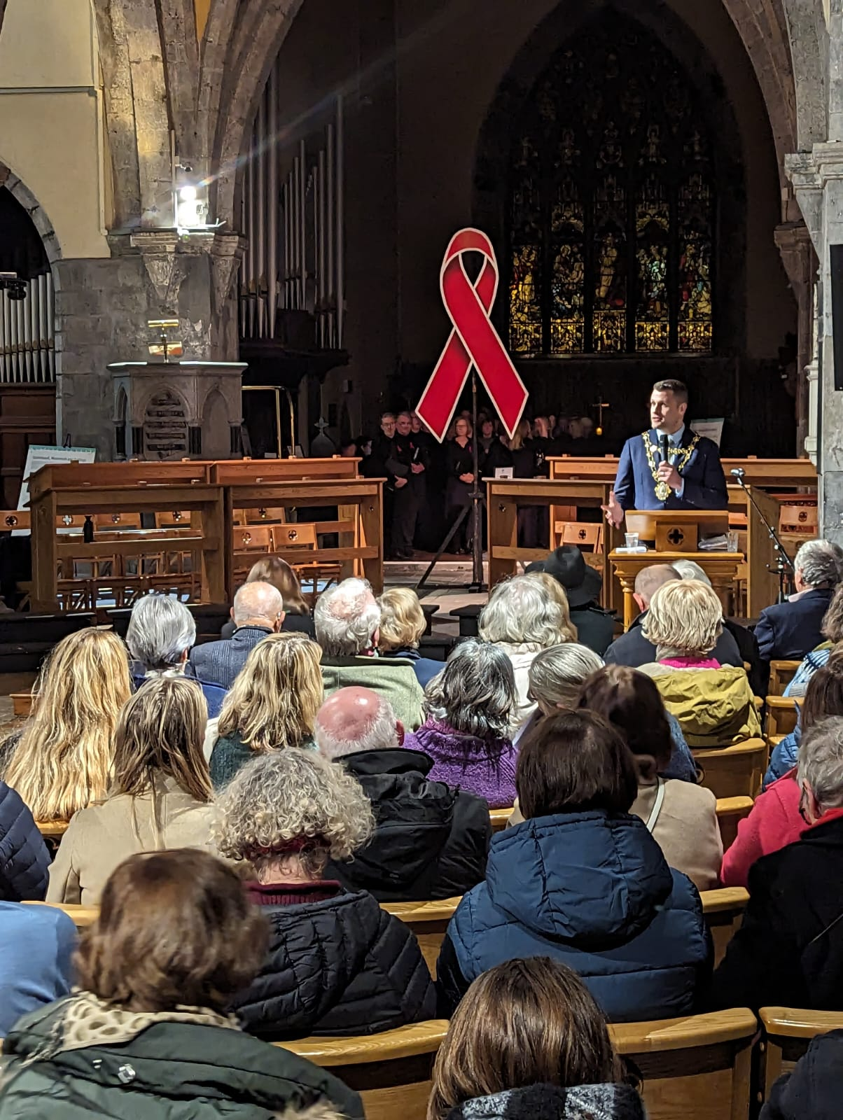
The Mayor of Galway speaking at The World AIDS Day Concert

HSE National Condom Distribution Service (NCDS)

Prior to COVID 19 restrictions condoms and lubricant were distributed to service users through our office and through our outreach services. Along with the walk-in service, condoms were distributed at community events, student health fares in NUIG, GMIT, Athlone IT, and Sligo IT. We were also in contact with local community groups such as LGBT+ Group Teach Solas and also Direct Provisions Centres to share protection packages of condom & lube with the services.
We also promoted the service at key dates in the calendar i.e. Irish AIDS Day, World AIDS Day, SHAG (Sexual Health Awareness & Guidance) Week in Third Level Colleges, and at various Pride events across the region.
SHW continue the condom and lubrication mailing service. Clients can request protection through our online registration form which is in line with HSE National Condom Distribution Service (NCDS) guidance. Once the form is completed it is put onto our internal system and the request is processed. Along with condoms and lubricant a SHW information booklet and an HSE condom booklet is also included in the package.
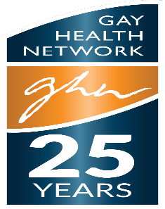
The Gay Health Network
Sexual Health West continued to be an active member of the Gay Health Network Ireland across 2023– we congratulate them, and wish them continued success.

Fast Track Cities
The Fast-Track Cities initiative is a global partnership between cities and municipalities around the world and four core partners – the International Association of Providers of AIDS Care (IAPAC), the Joint United Nations Programme on HIV/AIDS (UNAIDS), the United Nations Human Settlements Programme (UN-Habitat), and the City of Paris.

Mayors and other city/municipal officials designate their cities as Fast-Track Cities by signing the Paris Declaration on Fast-Track Cities, which outlines a set of commitments to achieve the initiative's objectives. Initially heavily focused on the 95-95-95 targets, the Paris Declaration was recently updated to establish attainment of the three 95 targets as the starting point on a trajectory towards getting to zero new HIV infections and zero AIDS-related deaths.

In 2019 Galway joined the Fast Track Cities partnership with Dublin, Cork & Limerick and throughout 2020 & 2021 developed a steering group and terms of reference to guide the partnership. This steering group comprises representatives from SHW, Galway City Council, UHG Infectious Disease Clinic, HSE Health Promotion, Dept of Health, Healthy Galway City. We are also looking for representation from PLHIV. SHW Chair the Galway Fast Track Cities Initiative.

The HSE Sexual Health and Crisis Pregnancy Programme have commissioned a HIV Scoping Study, with various stakeholder groups invited to participate in the HIV scoping study including;
- People living with HIV
- HIV Networks
- HIV Clinical Care providers (doctors, nurses and medical social workers)
- NGOs/Community organisations that provide HIV prevention and/or support services
- City Structures (including Local Authorities, Healthy Cities & Counties, HSE H&W, HSE Social Inclusion)
- HSE Departments of Public Health and HPSC

The commissioned research company are continuing to analyse the data, and will shortly begin drafting chapters. A study advisory group was established when the research company was commissioned, consisting of representatives from the city Steering Groups. The study advisory group is overseeing the progression of the scoping study and will provide input and feedback on draft chapters as they come through
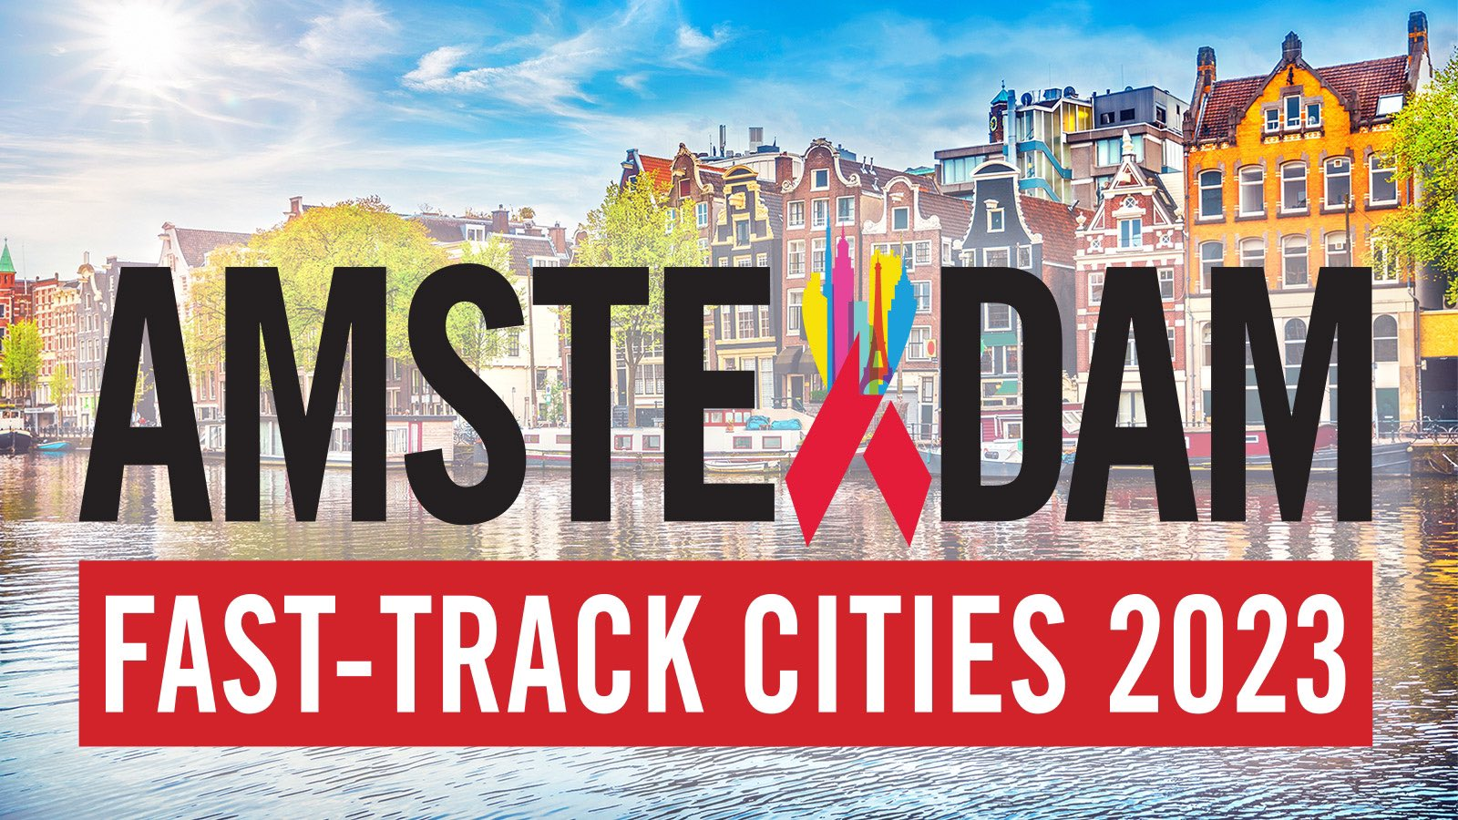
Fast Track Cities Conference – Amsterdam
Achievements
Education Sessions Delivered 213
Attendees 4,750
Number of new HIV clients 14
Helpline / Information calls / Condom requests 2,120
Condoms distributed 24,000+
Website Views 15,000+ new users
Worldwide APP downloads 111,000+
The figures for 2023 indicate continued new referrals of HIV Positive clients and the essential need for continued support to new and existing clients. There has also been an increase in the demand for help & information, including condom requests through our links with the HSE National Condom Distribution Service.
In response to the rising numbers of new diagnoses of HIV, Sexual Health West continued to offer a free community based Rapid HIV & Syphilis Testing Service across 2023.
Our Social Media presence continues to grow with an increased engagement with accounts by 20.2%, as we plan weekly posts, with additional promotional posts for testing. Our content includes the "Factual Friday" section, "Contraceptive Corner," and "STI Spotlight."
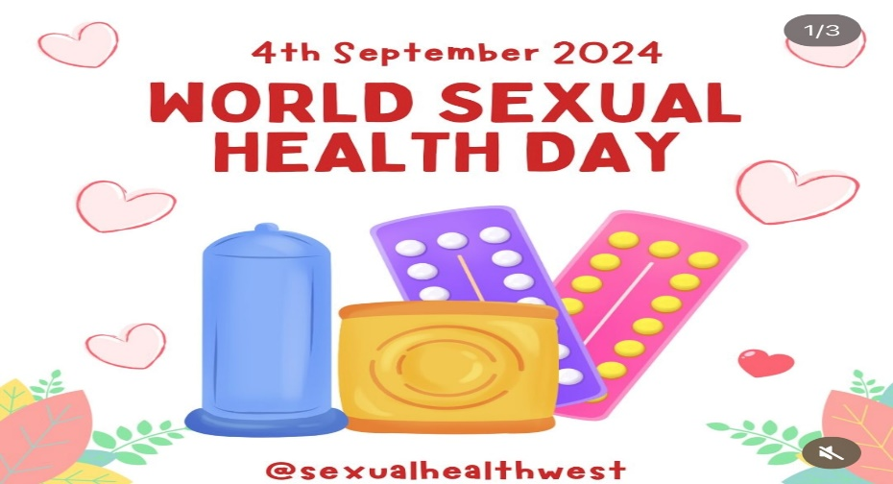
A number of years ago, Sexual Health West developed Ireland’s only Sexual Health App – this has seen an incredible 110,000+ downloads up to end of 2023, however we are now aware that we need to review its viability as people now access information through different elements of social media, including our website(s) with 15,000 new visits across 2023.
The sexual health education team were able to further develop their programmes to groups in schools and across the community once again. We have continued to offer links to the creative and exciting new virtual / on line resources to be found on the WISER Website (West of Ireland Sexuality Education Resource) www.bewiser.ie.
In summary, with an increase in new referrals of people newly diagnosed with HIV, the demand for HIV support services continues to grow. The WISER Sexual Health Education programmes continue grow and are essential in raising awareness amongst young people and other groups considered to be at risk.
Partnerships & Networking
Sexual Health West fully embraces partnership working and the importance of networking locally, regionally & nationally. We thank the following partners throughout 2023 for their support:
University Hospital Galway Infectious Disease Clinic
Irish Sexual Health & HIV Network
HSE Health Promotion
HSE Sexual Health & Crisis Pregnancy Programme
HSE Sexualwellbeing.ie
HSE KnowNow
Fast Track Cities
Galway LGBT+ Inter Agency Forum
Amach!LGBT+
Teach Solais Resource Centre
National HSE Irish Sexual Health Communications Group
National HSE Irish Sexual Health Migrant Communications Group
Western Region Drugs & Alcohol Task Force
NUI Galway Health Promotion
NUIG Student Welfare Team
NUIG Student Union
NUIG GigSoc (Gay in Galway)
NUIG Psychology Dept
USI (Union of Students in Ireland)
USI Pink Training
NUIG Child & Family Research Centre
GMIT Student Welfare Team
GMIT Student Union
The SVP
Sexual Health Centre Cork
GOSSH Limerick
HIV Ireland Dublin
Foroige
Youth Work Ireland
Rape Crisis Centre / Women’s Refuge
National Learning Network
Irish Family Planning Association
National & Second level Schools
PLC Colleges
Third Level Colleges
Youthreach Centres
GRETB
Family Resource Centres
Galway Rural Development
Healthy Ireland
Healthy Galway City
Healthy Co Galway
Community Centres, Groups & Organisations
Direct Provision Centres
Prison Services
Probation Services

Governance Code & Management
We fully comply with the Governance Code for community, voluntary and charitable organisations in Ireland. We confirm that a review of our organisation’s compliance with the principles in the Code has been completed based on an assessment of our organisational practice in line with the recommended actions for each principle.
• Principle 1 Leading our organisation
• Principle 2: Exercising control over our organisation
• Principle 3: Being transparent and accountable
• Principle 4: Working effectively
• Principle 5: Behaving with integrity
We confirm that our organisation is committed to the standards outlined in these principles.
We commit to reviewing our organisational practice in line with the recommended
actions for each principle each year following our initial review.
In 2018, the Charities Regulator announced a new Governance code for Charities which
would facilitate the better administration, management and governance of charitable
organisations.
Principles of Charities Governance Code are:
1. Advancing Charitable Purpose
2. Behaving with Integrity
3. Leading People
4. Exercising control
5. Working effectively
6. Being Accountable.
Thank you for your continuing trust and support
The Board of Management of Sexual Health West.

Schedule 1 Employees
Role | Name | Qualification
CEO | Joe McDonagh | Graduate Diploma - Careers Guidance, University of Kent  Diploma - Connexions Personal Adviser, Manchester University  Post Graduate Diploma - Family Support Studies, NUI Galway  M.A in Family Support Studies, NUI Galway
Support Service Co-ordinator | Nicole McGuigan | M.A in Family Support Studies, NUI Galway  B.A. in Psychology & Health Studies, NUI Galway  Diploma in Psychology of Counselling, NUI Galway  Diploma in Marketing, GMIT
Sexual Health Education Co-ordinator  Sexual Health Educators | Lorraine O’ Connell  Denise McAlister  John Halloran | M.A Sexuality Studies, DCU Dublin  B.A in Psychology, Sociology and Political Sciences, NUI Galway  Post Graduate Diploma in Health Promotion, NUI Galway  BSc. Psychology, University of Ulster  PGCE, Liverpool John Moore University  Graduate Certificate in Sexuality & Sexual Health, DCU  BSc. Psychology, University of Sterling  MSc. Psychological Research methods specializing in Child Development, University of Sterling
Education Co-ordinator Drugs & Alcohol | Neil Wilson | B.A. in Theology, Durham University  P.G.C.E. , Cambridge University  Diploma in Drugs & Alcohol Studies NUI Limerick
Office Co –ordinator  Admin Support | Josephine Mohan  Kieran Browne | Secretarial Qualification in Administration and Finance  ECDL

Schedule 2 Board Members
Name | Workplace | Occupation
Patrick Towers | Currently on Special Projects | Chair of Board  Former Rector St Nicholas Church
Dr Claire Connolly | Dept of Health Promotion, NUIG | Company Secretary of the board of Sexual Health West  Lecturer in Health Promotion  Recently retired
Maria Molloy | University Hospital Galway | Surveillance Scientist, National HCAI/AMR Implementation team
Dr Andrea Holmes | Bon Secours Hospital, Galway | Consultant in Infectious Diseases & Genitourinary Medicine  Medical Director of Galway Sexual Assault Treatment Unit
Suzanne McKane | The BRIDGE Project, Galway City Partnership | Project Coordinator
Des Tomlinson | Irish Football Association | Intercultural Football National Coordinator
Joseph Nyirenda | NUI Galway | Programme Coordinator

Acknowledgements
Sexual Health West would like to express our sincere thanks to all those who have worked with us and supported us during 2023:
- To our principal funder, the Health Service Executive CHO2, the HSE Sexual Health & Crisis Pregnancy Programme and also to the Western Regional Drugs & Alcohol Task Force.
- We would like to thank Michael Keady, Dympna Smyth & Gerry Burke from HSE CHO2, and also Maeve O Brien, Janice Donlon, Caroline Hurley, Rachael Metrusty, Orla McGowan, Trish Wallace and the team in the Sexual Health and Crisis Pregnancy Programme for their ongoing support.
- To our many sponsors and donors, without whose kindness and generosity many of the programmes we undertook could not have happened, in particular to M.A.C Cosmetics, GSK, Gilead, Galway City Council & Galway County Council, LCDC.
- We would particularly like to thank the staff at the Infectious Disease Clinic at UCHG with whom we share a special working relationship.
- We acknowledge the ongoing partnership with numerous departments within NUI Galway.
- We appreciate the support and shared knowledge & advice we get through partnerships with GOSHH in Limerick, The Sexual Health Centre in Cork and HIV Ireland in Dublin.
- A special thanks to the board of management of Sexual Health West.
- And last, but by no means least, to the excellent staff team at Sexual Health West and to all of our volunteers.

Sexual Health West - Continuing the essential work of supporting people living with HIV

Sincere thanks to our core funder:
