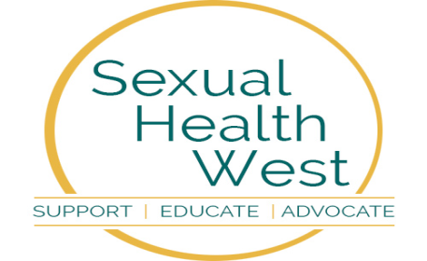
Sexual Health West
Annual Report 2024


Organisation Address (registered office) and contact details:
Sexual Health West
Ozanam House
St Augustine St
Galway
H91 VP3V

Charity No: 11278
Reg No: 228073

Introduction
Sexual Health West (SHW) is a not for profit Non-Governmental Organisation (NGO) limited by guarantee.
Sexual Health West is a West of Ireland based charity working in the area of HIV and sexual health, our offices are located in Galway. Our primary function is to provide support for people living with HIV, we also deliver extensive education programmes and information in relation to HIV and sexual health. We are funded by the HSE, and also receive income through donations and sponsorship. Established in 1987 as Galway AIDS Alliance, in response to the global pandemic of HIV/AIDS, we always strived to serve our community with care and compassion. Our role has evolved and expanded from the initial group of dedicated volunteers into a professional, committed team.
We aim to encourage the development of openness and honesty around HIV and sexual health issues in Ireland. Sexual Health West is known as a centre for reliable, informed and up-to-date information regarding all aspects of HIV and sexual health. We offer evidence-based skills training and support for people with issues about HIV, sexuality and relationships. Through our education programmes, we look to limit future transmission of the HIV virus and reduce the impact of the negative consequences of sexual activity such as the transmission of STIs (Sexually Transmitted Infections) and the potential for unplanned pregnancies. Our free community based Rapid HIV testing service encourages easier access to HIV testing services with the aim of reducing onward transmission of the virus whilst also linking people with treatment and support services earlier if necessary.
Chairperson’s Note
Sexual diseases such as Chlamydia trachomatis, Gonorrhoea, Herpes simplex and HIV, if not treated can become nasty and seriously affect sexual health and can significantly disrupt a person’s physical and psychological well-being. Sexual Health West is in the front line ensuring that these infections are rigorously treated either providing STI testing to see whether a person is affected, giving advice as to where medical help is available or referring a person who might be a sufferer to the HSE clinics.
The SHW team, under our CEO are also there to educate through the WISER programme, a sound knowledge of Sexual Health. The WISER team encourage conversations around sexual health, and give time to listening closely to those they are addressing. Importantly they know how essential it is to build trust with those with whom they engage. All of us in SHW are keen to embrace patterns of behaviour that make a difference to our society.
I want to express my deep appreciation to all those who are involved with SHW. With our highly informed and skilful team members, with our Secretary and with our highly accomplished CEO. Then there are the Board of Trustees who give freely of their time to ensure that we are compliant with the guidelines of the Charity Regulator. They give their invaluable oversight to our finances and proper ordering and governance to our organisation. I wish to express gratitude to our generous stakeholders.
Without the leadership skills of our CEO, we would not be in the position to deal so ably with those whose grants help fuel our visions for a sexually healthy society.
Thank you all, past and present members of ‘Aids West’ now ‘Sexual Health West’. You are stars!
Patrick L. Towers (Chairperson)
CEO's Foreword
I am delighted to present the Sexual Health West Annual Report for 2024. This report is an opportunity to reflect on the work undertaken by Sexual Health West over the past year and it gives an insight into the many services that we continue to provide and develop. In this report, you will find details of the various activities and initiatives that Sexual Health West has undertaken over 2024, including some of the key achievements, challenges, and contributions made throughout the year.

These achievements include:
Continued support to People Living with HIV – both new referrals and existing service users living with HIV
Expansion of the Rapid HIV & Syphilis Testing Service
Development of National SH:24 Home Testing Service
Expansion of HSE National Condom Distribution Scheme
Delivery of the WISER Programme to schools and other educational centres
Delivery of Sexual Health Promotion Programmes to a wide variety of stakeholders including, IPAS Centres, The Ukrainian Community, Disability Sector, Child and Adolescent Mental Health Service (CAMHS), Irish Defence Forces, Traveller & Roma Communities,
Further expansion of the Galway Sexual Health Forum
Partnership working with University of Galway Dept of Health Promotion hosting students
Actively addressing the Sexual Health needs of communities across the region through initiatives including Menopause Café Workshop, Period Dignity Project 2024, a HSE Menopause Seminar, and involvement in Galway, Mayo & Roscommon Pride 2024
Contributing to national and local advisory committees i.e. INISH Steering Committee, Belong Too Advisory Group for EmpowerHER.

I would like to take the opportunity to thank the Board for their support and guidance to the organisation and to myself. I would like to thank the Staff Team and Volunteers at Sexual Health West for their dedication and support over the last year - it is your commitment and enthusiasm that have made Sexual Health West’s achievements possible. In 2024, we welcomed three new staff members, Ciara Mulgrew and Saoirse Browne joined the team in the role of Sexual Health Educators, and Hope Turner joined us in a HSE funded role as the Fast Track Cities Project Manager for Galway. I also wish to thank our stakeholders, funders and donors for their support, which enables us to deliver our services across the West of Ireland. I would like to wish our colleague Kieran Browne well in his retirement after 25 years of service to the organisation – thank you Kieran.
I want to thank all those we work with, individuals, schools, colleges, community groups and organisations for their continued support.

Sexual Health West continues to offer a range of essential services to all communities, as we look forward to supporting the implementation of the next HSE National Sexual Health Strategy in 2024/2025.

Joe McDonagh, CEO - Sexual Health West
MISSON STATEMENT & OBJECTIVES

Mission Statement
Sexual Health West is a charity which provides a safe and welcoming environment for everyone with whom it works. Our office is based in Galway.

Our Mission is to:
- Deliver the highest quality care and support to people living with HIV/AIDS or STIs.
- Empower those living with HIV to optimise their health and well-being.
- Raise awareness around HIV/AIDS, and STI issues and work to eradicate stigma and discrimination.
- Promote positive sexual health without prejudice or discrimination.

Objectives
- Deliver the highest quality care and support to people living with HIV/AIDS or STIs

Support
- To offer emotional/psychological support to people living with HIV/AIDS or STIs according to their stated needs and to the ability of Sexual Health West to deliver those supports.
- Support may be by telephone, email, or by face-to-face meetings with the coordinator.
- Telephone Helpline support may be offered by other Sexual Health West staff.
- Support groups or ‘buddying’ by similarly affected people may be offered.
- If deeper psychological support is needed a person may be referred to a Psychotherapist or more appropriate counselling services.
- Support may also be offered to a person who makes contact who is experiencing a sexual health crisis or problem.

Care
- Offer practical assistance to people living with HIV/AIDS or STIs e.g. in finding suitable accommodation or in obtaining social welfare benefits.
- May provide complementary/holistic therapies for the physical/holistic wellbeing of the person affected.

To empower those living with HIV to optimise their health and wellbeing
- Workshops on different aspects of personal development facilitated by experienced practitioners are offered from time-to-time to people living with HIV who use the Sexual Health West Care and Support services.
- Workshop topics will include areas such as:
Improving self-esteem
Fighting against stigma
Campaigning for the best possible support services and treatments

Raise awareness
- We raise public awareness of HIV/AIDS, STIs and sexual health through awareness campaigns, provision of information material, use of various media, seminars, publication of a newsletter and public events.
- Provide a confidential Helpline / Information Service on HIV/AIDS, STIs and sexual health matters.
- Ongoing use of technology to provide information on HIV/AIDS, STIs and sexual health by maintaining up to date information on our website www.sexualhealthwest.ie the WISER website www.bewiser.ie and the Sexual Health App.
- Draft and publish leaflets, posters, brochures and booklets on sexual health matters for information and distribution to health clinics, doctor’s surgeries, seminars, conferences, colleges etc.

Promote positive sexual health
- We will enhance sexual well-being by the provision of responsive and innovative training programmes to schools, community groups, youth organisations etc and work in conjunction with state agencies to provide these programmes where appropriate.
- We will provide outreach programmes for at-risk groups i.e. LGBT+ community, asylum seekers, prisoners and many others in the form of education, support, advice and provision of free condoms.
- We will provide outreach services to young people who are potentially at risk and who are not in contact with other services.
- We will work with the Western Region Drugs & Alcohol Task Force [WRDATF] to deliver holistic educational programmes linking sexual health with substance and alcohol abuse.

Best Practice
- Participate in research on sexual health, disease prevention and best care practice.
- Participate in national/local meetings and networks/associations in order to
develop and maintain models of practice.
- Work with HSE and community groups in the development and delivery of “Train the Trainers” programmes to schools, community groups etc.

Report on Activities 2024
In addition to education and prevention initiatives, throughout 2024 we have continued to provide professional and responsive care and support services to anyone who is living with HIV and other STIs, as well as for those who have worries about their sexual health.
We do this by:
- running awareness campaigns and providing information to the general public through our media channels
- providing targeted education and outreach through partnerships with community organisations and programmes
- responding to specific queries directed to us from individuals through email, phone and social media channels
- providing a comprehensive condom service that includes information provision on good sexual health
- maintaining a close relationship with our hospital colleagues in the GUM clinic
- being available at short notice and quickly acting on new referrals when people are going through crisis periods
- supporting families of those affected by HIV & STIs
- having contact with our client group through a regular newsletter
- meeting up with clients face to face, online and providing phone support
- organising gatherings and events where possible for people to meet in groups and peer support
- ensuring other opportunities for peer support through national events and initiatives

Support Services - People Living with HIV & Sexual Health Support
Sexual Health West’s Support Services include one to one support, advocacy, and counselling for people living with HIV (PLWH) or affected by HIV. We also respond to public queries in relation to HIV and STIs – in person, through our Website and through social media. We support people newly diagnosed with HIV as well as service users living with HIV for a number of years. We support those living in Direct Provision Centres and International Protection Accommodation Services, Ukrainian Refugees. The kind of support need can vary from the anxiety and shock of an initial diagnosis, to issues relating to mental health, disclosure in both personal relationship, to family and friends and in formal settings for example employment situations. The support is offered unconditionally, and service users can choose to withdraw or re-engage at any point.
Throughout 2024 we have continued to provide support to our current client group as well as furthering our support to new clients who are living with HIV and other STIs or worries about their sexual health. We have also continued to reach out and respond to enquiries from other agencies, organisations and the general public, with sexual health information and support.
We do this by:
- meeting up with our client group face to face, online and providing phone support
- supporting families and partners of those affected by HIV & STIs
- organising gatherings and events where possible for people to meet in groups and peer support
- ensuring other opportunities for peer support through national events and initiatives
- responding to specific queries directed to us from individuals through email, phone and social media channels
- quickly acting on new referrals and being available at short notice when people are going through crisis periods
- running awareness campaigns and providing information to the general public through our media channels
- providing targeted education and outreach through partnerships with community organisations and programmes
- providing a comprehensive condom service that includes information provision on good sexual health
- maintaining a close relationship with our hospital colleagues in the GUM clinic

We offer a regular presence for patients linked to University Hospital Galway, face to face meetings and support, the World AIDS Day Concert and events, attending community open days, participating and networking with community forums and meetings, and offering HIV & Syphilis testing in multiple community locations as well as supporting home testing through SH:24. Through these events, our presence in the community has increased significantly.
We receive referrals from a number of routes, with many referred through the GUM clinic while people also contact us through email, social media and website and they are responded to promptly by a member of our team. Our support service meets clients in Galway as well as continuing to offer outreach in County Galway, County Mayo and County Roscommon & County Sligo. We continue to develop our partnerships with linked ogranisations locally and across the region including Amach, Outwest, through Pride Festivals, community centres and family resource centres, third level institutions, IPAS Centres, Direct Provision Centres and with Ukrainian communities.

WISER (West of Ireland Sexuality Education Resource)
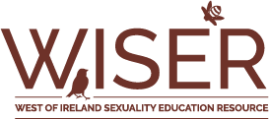

The WISER (West of Ireland Sexuality Education Resource) education team are part of Sexual Health West. Staff members are highly trained, experienced and enthusiastic about delivering Relationships and Sexuality Education. Our programme(s) provide evidence-based, factual, non-judgmental sexual health information on topics such as:
- Consent and Relationships
- Contraception, Protection and STI’s
- Anatomy, Reproduction, Sex and Pleasure
- Gender Identity and Sexuality
- Nudes, Pornography and IBSA (Image Based Sexual Abuse)
- Support Services for young people

As WISER educators, we continuously update our content and facilitation style to ensure we are delivering comprehensive, factual, progressive, inclusive, empowering, age-appropriate, non-judgemental and sex-positive Relationship and Sexuality Education.

Comprehensive sex education programs have demonstrated the reduction rates of early sexual activity, risky sexual behaviours, STIs, and adolescent pregnancy. Many literature reviews have indicated that comprehensive sex education promotes healthy sexual behaviours, such as:
- Reduced sexual activity.
- Reduced number of sexual partners.
- Reduced frequency of unprotected sex.
- Increased condom use.
- Increased contraceptive use.
However, comprehensive sex education curriculum such as WISER, goes beyond risk-reduction, by covering a broader range of content that supports social-emotional learning, positive communication skills, and development of healthy relationships.

Implementation of recommendations from the evaluation of the WISER Secondary School Programme (2022-2023)
University of Galway evaluated the WISER programme in 2022-23. The results gleaned from the in-depth interview with the educator, a key stakeholder in the WISER programme, shed light on various aspects of the program. It emphasized the importance of regular team contact, a well-trained and cohesive team, and ensuring staff undergo Garda/Police vetting and child protection training. The interview revealed the need for a comprehensive training manual or toolkit to support new trainers and ensure program sustainability. It also highlighted the programme’s adaptability and dedication to evolving the curricula based on learners' needs and transferring organisational expertise to new personnel.
The manual is a work in progress and will continue to be compiled during 2025. This will be a document that will continue to evolve with the constant updating of programmes. Updating sexual health programmes is crucial to keep up with changing sexual health challenges such as rising STI rates and misinformation, and to promote positive sexual health and well-being.
Regular updates ensure that information is current; services are accessible and tailored to diverse needs.

A Little WISER (Primary School Programme)
Our Little WISER programme began delivery in May, with parenting events running from Feb into April. We continued the delivery of parent’s/guardians information evenings online, due to the success from previous years. All primary school programmes were very well received from young people, and all other stakeholders. We did expand our reach in 2024, but continue to have requests made from other primary schools in Galway and Mayo. As highlighted previously, a large amount of time and resources go into the delivery of this programme, but the need and demand is there to expand further.

Work Placements with University of Galway
University of Galway Health Promotion Student Placements within Sexual Health West
We facilitated two Health Promotion Students this academic year. The days of placement have reduced; therefore, we did our best to support the students where required. We set tasks, objectives and looked at the associated Health Promotion Competency. The education coordinator held regular supervision with the students.
We continue to work with University of Galway annually in facilitating placements from the Health Promotion Department and the collaboration works very well, with both the students and the college sending back very positive feedback.

Community Psychology Students
We had been contacted by the Psychology Dept. requesting a meeting to discuss a site visit by students. They conducted an interview with the education coordinator regarding our service and volunteering opportunities.
The collaboration between Sexual Health West and the Psychology Dept. in University of Galway continued over 2024, with some students trained to become Rapid HIV Testers and hope to support the testing coordinator in Galway city venues.

Community based Sexual Health Workshops 2024

Accompaniment Support Services for Children (ASSC)
A sexual health workshop was provided to the staff of ASSC on ‘Examining Sexual Cultural Differences’. This was not something we had done previously and entailed a large amount of research to meet the needs of the group.
ASSC is an Irish organisation that provides support and advocacy to young people and their families navigating the criminal justice system and related services, such as sexual assault treatment units and court proceedings. ASSC offers various forms of accompaniment and support, including in-person assistance at facilities like Barnahus West. The organisation was delighted with the delivery of the session and information received.
Child and Adolescent Mental Health Service (CAMHS)
Sexual Health West worked for the first time with CAMHS in 2024, we offered a number of topics to staff with the following deemed to be the most relevant: Gender identity and sexual identity, Image Based Sexual Assault, Cultural Competence and Consent. We delivered two, 2 hr workshops to the community and inpatient staff. Following delivery, we received excellent feedback from the CAMHS Training Coordinator and the participants involved.

Renmore Barracks:
Once again, Sexual Health West provided a workshop with new recruits. There was particular interest in STI’s, Testing, Contraception, Protection and Support Services. Participants gave excellent feedback in their evaluations with the facilitators making note of how engaged recruits were with the topics discussed.

Youthreach Centres
We delivered our Youthreach RSE programme in a number of centres throughout Galway across the region.
Dochas
Continued our delivery with clients in Dochas.

Disability Groups
National Learning Network
We continue to work with the NLN in Galway city, providing a number of sessions throughout the year for their service users.

Rehabcare
Over 2024, we expanded our work with Rehabcare delivering to services in Galway, Mayo and Roscommon. There are no other services in the west providing sexual health workshops for young and older adults with an intellectual disability. People with disabilities require access to inclusive and accessible sexual and reproductive health services, including sex education, family planning, contraception, and support for sexual and reproductive rights. Due to existing barriers such as inaccessibility and lack of staff knowledge, this leaves increased vulnerability to sexual abuse and exploitation. Ensuring these services are available is crucial for promoting disabled people's autonomy, well-being, and human rights. We could easily expand delivery in this area if we had further resources.

IPAS Centres
We continue to engage and work with the IPAS Centres across the region, and we have developed good relationships built with the Migrant Peer Support Workers, and hope to increase the work that we can carry out in 2025.

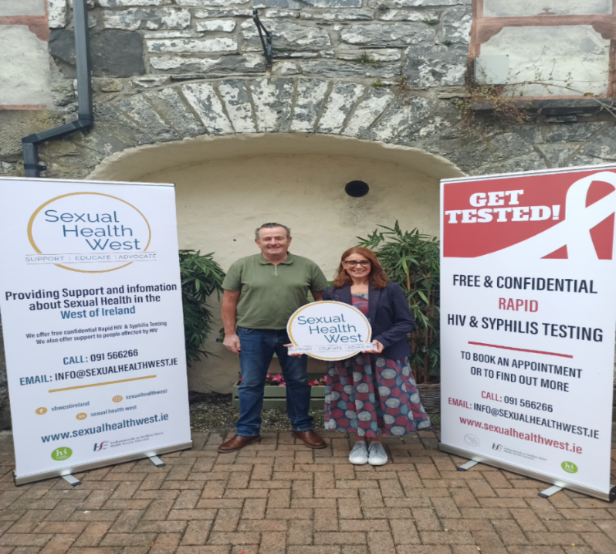
SHW at IPAS Centre Castlebar
Men’s Sexual Health Workshops
The education team delivered a number of workshops in Co Mayo, working in two centres in Castlebar and one in Ballyhaunis.
Women’s Sexual Health workshops
We covered a number of centres in Galway city and offered workshops for both parents and younger groups within the centres.
We provided workshops in Mayo for women only, as requested by the residents.
Where feasible we continue to offer testing in centres after the workshops are complete.

Ukrainian and Roma Communities
Women’s Health
Sexual Health West in collaboration with Galway Rural Development hosted a successful
Women’s Health event in Carraroe, promoting local services such as Domestic Violence Response, Health Promotion, Galway Rape Crisis and Sexual Health West for Ukrainian women living in the area. We had an interpreter at the event had a meditation session, provided childcare and some light lunch.
Sexual Health Workshops
We held a workshop for younger and older Roma girls in Ballaghaderreen Family Resource Centre, providing information on Puberty and Reproductive Health. The Family Support and Community Development worker informed the local school and youth services. We had a great turnout for the workshops and provided free period products to the participants.
Information Sessions for Parents
Working with the Ukrainian Support Worker from Galway Volunteer Centre, we had a parenting session discussing topics of interest such as: helping your young person navigate the negative impacts of Pornography, Image Based Sexual Abuse, Consent, Relationships and Support Services.
This was a well-attended event; we had both parents and grandparents present, with great engagement and feedback.

Other areas of work and engagement in 2024
INISH Steering Committee
The education coordinator was invited to become a member of the INISH Steering Committee at the end of 2023 (the new national survey on sexual health). Meetings took place over 2024 and sexual health west continue to have the opportunity to be involved in overseeing the survey.
The results will inform decisions on sexual health policy and services in the country.

Belong Too Advisory Group for EmpowerHER
EmpowerHER aims to provide a safe, inclusive, and youth-led space for co-developing and enhancing sexual health knowledge, fostering positive relationships, and promoting overall well-being among young LBT+ women.
We were invited to become a member of the Advisory Group, which will provide expert knowledge in the areas of youth work, sexual health and wellbeing, and the LBT+ community. Members support the facilitator with expert input in developing specific modules. The group will also meet three times during the project lifecycle: for an information session, a review meeting of the first draft of the training guide, and the final sign-off on the project. We have attended meetings and contributed to the content of modules over 2024.

Galway Pride 2024
Sexual Health West were present throughout the week of Pride in Galway at the community hub in Amach. We offered Rapid HIV testing over the week and provided an information stand, and had great engagement with those who attended. Through events such as information evenings, panel discussions, and workshops, Galway Pride educates the community and organisations involved in LGBTQ+ experiences. This has been a great collaborative piece between Amach, Sexual Health West and Galway Rape Crisis

HSE Menopause Seminar
Sexual Health West were invited to host a table at ‘Let’s talk about Menopause’ in Galway city, held by HSE and GRD. We also had an information stand and through this, a request was made that we speak at an event in Galway County in the coming weeks.

Menopause Café Workshop
The Education Coordinator facilitated a two-hour workshop in Headford, discussing Menopause and Sexual Health. It was very well attended, with many questions being asked, which highlighted the importance of the topic amongst younger and older females.

Period Dignity Project 2024
Healthy Galway City invited Sexual Health West to be a part of this project to mitigate the impact of period poverty in communities across Galway City.
The Council had been awarded funding under the Dept. of Health, Period Dignity Fund 2024, for the provision of period products in venues that are managed or supported by the local authority.
In 2024, they hoped to expand the project to additional venues and reach even more people who would benefit from this initiative. Sexual Health West are delighted to be a part of this valuable project and hope to continue working with the council in 2025.

Conferences and Training
Fast Track Cities Conference Paris 2024
Attended the conference as a representative from Sexual Health West in Paris in October 2024. We met with members of organisations from other countries and attended skills building workshops and plenary sessions. It was a fantastic opportunity to network with organisations working in the area of sexual health, with particular focus on HIV prevention and treatment.

Gay Health Forum Event 2024
Attended and presented at the Gay Health Forum Event in Dublin Castle in August 2024. Our presentation focussed on the need of a LGBTQ+ community based workshop. This stemmed from feedback we received in our school evaluation forms and current research highlighting the lack of relevant sexual health information for this cohort of young people. We plan to develop the workshop over 2024 and offer it to services in the west.

Training attended by the education team over 2024

- Sex Workers Alliance Ireland (SWAI) Sex Worker Awareness Training

- Irish Family Planning Association (IFPA) Speakeasy Disability Training

- National Youth Council of Ireland (NYCI) Understanding Young People and Pornography

- CPR Training

Provision of Sexual Health Information

NUIG Volunteer Fair(s)
Engaging with both staff and students, we provide students with information regarding volunteering opportunities and general information on what we do as an organisation.
ATU Health and Well-Being Week
Provision of Information and Testing offered at various campuses over the week.
ATU Gender Based Violence Week
Provision of information and sign posting to relevant services.
Men’s and Women’s Health events in the west
Our Information stands have gender specific information and signposting to relevant services. This is an excellent way of promoting what we do, and reaching rural communities that may not have access or awareness regarding particular services.
Over 2024, where feasible we offered Rapid HIV Testing and had great engagement during the events.
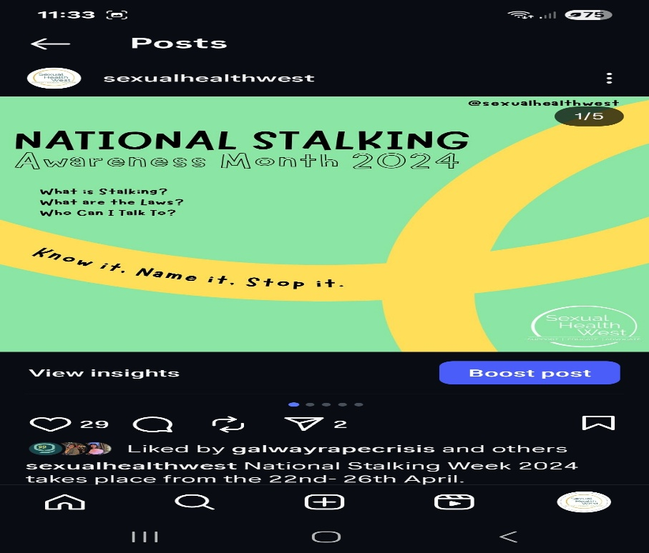
WISER Book – ‘Sex Educated’
Sex Educated was published in 2021. We continue to promote the book as a valuable resource for young people themselves and anyone with a young person in their lives, be it parents, relatives or anyone working with young people. Professionals have commented on the publication, holding it in high esteem for both its practicality and breadth of knowledge. We have incorporated illustrations from the publication into our WISER Programme to promote variety and diversity regarding our bodies and bodily functions.

The book can be purchased through the Sexual Health West website: www.sexualhealthwest.ie
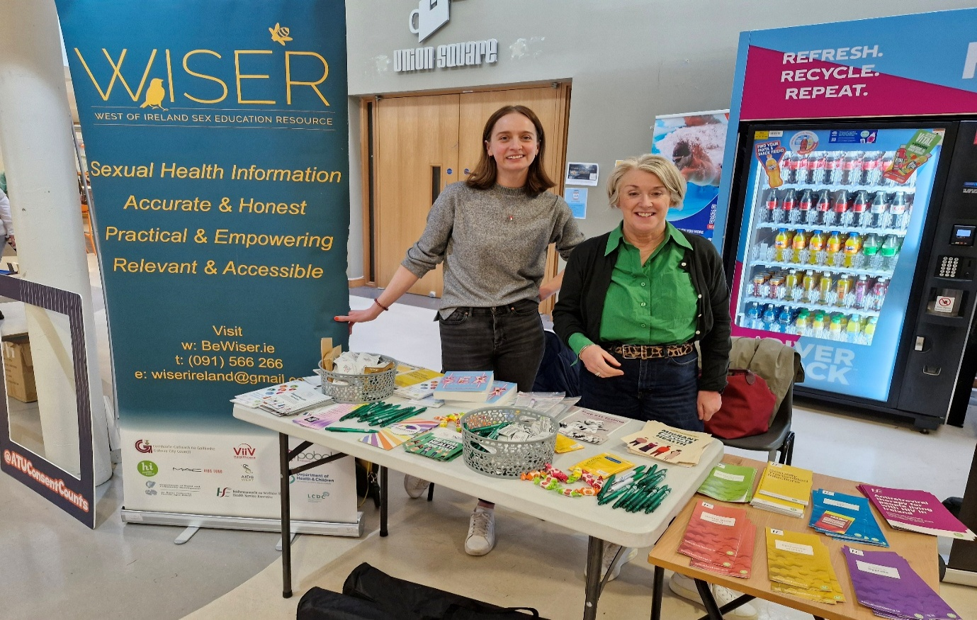
Providing information to GTI students on our service and offering opportunities to volunteer

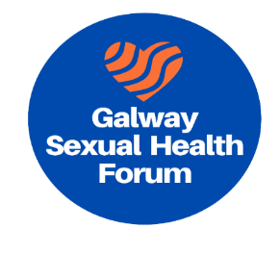
The Galway Sexual Health Forum
The Galway Sexual Health Forum was established in 2021, and continues to have successful meetings on a quarterly basis. Sexual Health West has chaired the forum since inception and is delighted with its success.
Its main purposes are to facilitate the provision of an excellent and integrated education, support and treatment continuum for all aspects of Sexual Health through the life course, and to contribute to the Sexual Health Strategy and policies. Forum members once again expressed the value of the forum to help disseminate information and the sharing of ideas, knowledge and opinions regarding sexual health. We are hoping to have more in-person meetings next year and host a Sexual Health event in Galway city. I would like to thank all those who are current members and we look forward to expanding in 2025.

Summary
There were challenges over the year, but once again, the WISER team went beyond expectations to deliver our vital service to individuals and groups in the west of Ireland. I wish to highlight the team’s exceptional work and unique skills, and sincerely thank them for their continued enthusiasm and commitment.
Drugs and Alcohol and the link to Sexual Health
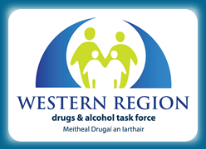
This year saw a broadening of the range of organisations and diversity of individuals who engaged with the various programmes that the WRDATF offered.
Expertise gained delivering courses online led to a greater range of opportunities to expand the offering of drug and alcohol education programmess. This meant that major programmes such as ‘Putting the Pieces Together’ and ‘Prime for Life’ continued to receive a notable amount of attention during 2024. In addition, new ‘in-person’ courses began to be rolled out, especially in relation to a GAA national initiative to bring interactive workshops to clubs around the region.
Meanwhile in the online world a great deal of planning and development fed into the establishment of a Parent Hub, whereby parents were enabled to engage in a series of sessions to support them in opening up useful conversations with their young people around substance use. This Hub was based on the schools programme for parents that continues to be a mainstay of our work in this area.
During the summer, the HSE continued to further develop their ‘safer nightlife’ harm reduction programme centred on the festival scene. This involved both on-site testing of drugs at the Electric Picnic event and outreach among the festival goers at a selection of summer music festivals. This has become a valuable resource in informing a range of colleagues on both the changing nature of available drugs and the social attitudes surrounding their use.
The awareness week of the WRDATF was once again completed on-line. A major contribution to its success was made through the development of presentations covering emerging areas of concern such as the use of vapes, semi-synthetic cannabinoids (e.g. HHC) and nitazenes.
Training was also developed to improve the capacity of professionals whose work brings them into contact with people who may consume drugs or have alcohol issues. Groups included the SAOLTA liaison group and several groups involved in delivering the national GAA programme concerning drug and alcohol use.
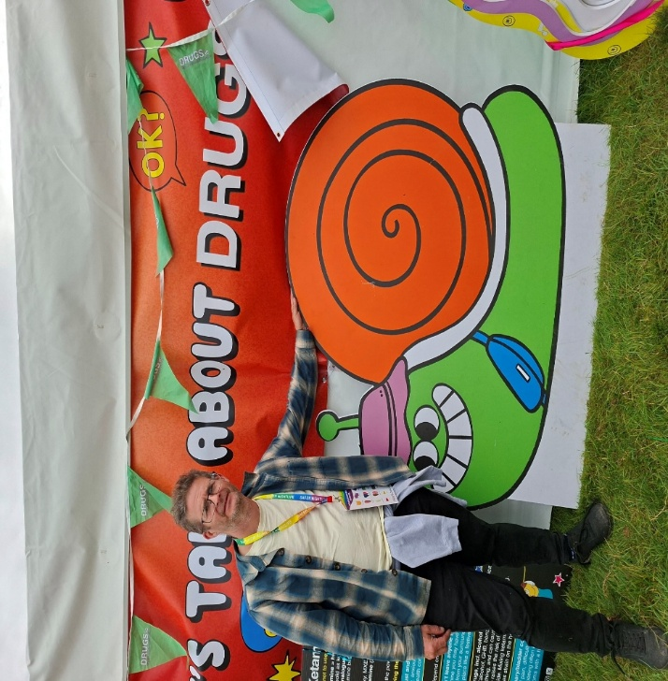
WRDATF at Electric Picnic
World AIDS Day 2024
This year’s theme for World AIDS Day on 1 December 2024 was “take the rights path“. The path that ends HIV/AIDS is a rights path. Upholding the United Nations Declaration on Human Rights, and fostering inclusion of all communities, is essential for ending HIV/AIDS.
The commemoration of World AIDS Day is an important opportunity to recognize the essential role that communities have played and continue to play in the AIDS response at local, national and international levels. Communities and NGO's like SHW contribute to the AIDS response in many different ways, for example through through leadership and advocacy.
We hosted the annual World AIDS Day Concert in St Nicholas’ Collegiate Church, Galway. The Deputy Mayor of The City of Galway Níall McNelis gave an introductory speech praising SHW West for its excellent work, and then the crowd were treated to a selection of carols performed by Cois Cladaigh, as well as the magnificent voices of Bel Canto. To all who attended on the evening and helped in making this such a fabulous event, in particular Patrick Towers, the compère of the concert and the wonderful staff team at SHW West, a very special ‘thank you’.
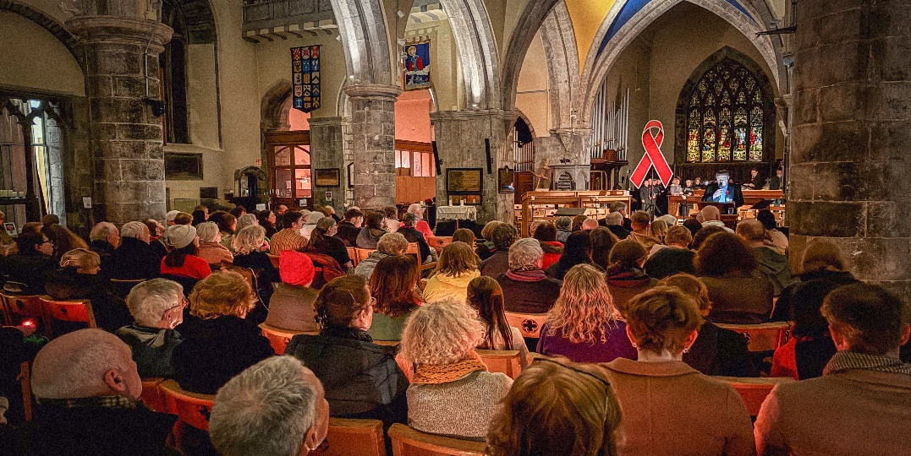
World AIDS Day Concert

HSE National Condom Distribution Service (NCDS)

SHW continue the condom and lubrication mailing service. Clients can request protection through our online registration form which is in line with HSE National Condom Distribution Service (NCDS) guidance. Once the form is completed it is put onto our internal system and the request is processed. Along with condoms and lubricant a SHW information booklet and an HSE condom booklet is also included in the package.
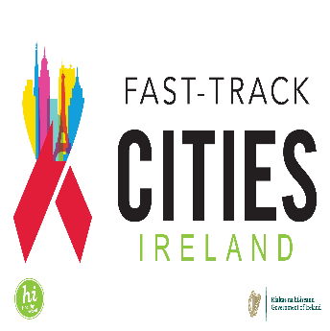
The Fast-Track Cities initiative is a global partnership between cities and municipalities around the world, and Galway signed the Paris Declaration on Fast-Track Cities in 2029, which outlines a set of commitments to achieve the initiative's objectives, with the aim of getting to zero new HIV infections and zero AIDS-related deaths.

Sexual Health West chair the FTC Galway steering group which comprises representatives from SHW, People Living with HIV, HSE Sexual Wellbeing, Healthy Galway, Galway City Council, Galway County Council, UHG Infectious Disease Clinic, HSE Health Promotion, Dept of Health, University of Galway, Amach.

The HSE Scoping Study of Available HIV Data, Services, and Support published in 2024, conducted qualitative interviews and consultation surveys to assess Ireland’s HIV services, both identifying challenges and gaps, and providing recommendations for local governance. The Sexual Health Programme conducted the study with input from regional Departments of Public Health, HSPC, HIV clinical services, community/member organisations, and people living with HIV. The key populations involved in HIV prevention & treatment identified in the HSE Scoping Study include: gay, bisexual, & men who have sex with men, people who inject drugs, people from migrant communities, people engaged in sex work, people in prison and probation services, transgender people, and those experiencing homelessness.
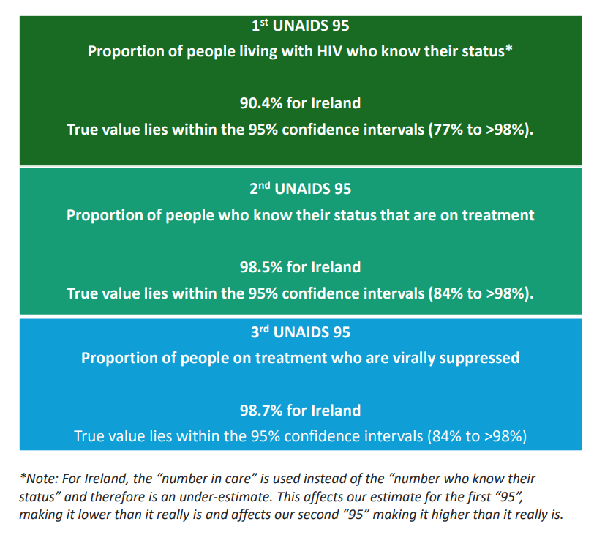
The Scoping Study provides up-to-date data on funding, clinical services, and community experiences for the design of a local Fast Track Cities Implementation Plan. The FTC Galway Steering Group operated under the 7 Scoping Study recommendations, and oversaw the Implementation Plan’s inclusion of 11 areas of recommendation. The following Fast Track Cities Implementation Plan aims to achieve the UNAIDS targets
The Fast Track Cities Galway developed a Steering Group in 2021 and then updated membership in 2024. The Steering Group consists of 11 stakeholders in Galway City and County, representing government health agencies, local health initiatives, nongovernmental organisation leadership, and Galway’s HIV clinicians.

People living with HIV sit on the Steering Group to represent the diverse community in the West of Ireland. Sexual Health West chairs the FTC Steering Group. Members are responsible for governance over the Fast Track Cities Implementation Plan development and delivery, while advising best practice, developing a consensus on action, and maintaining accountability. The Steering Group met monthly to advise on the Implementation Plan development in 2024.
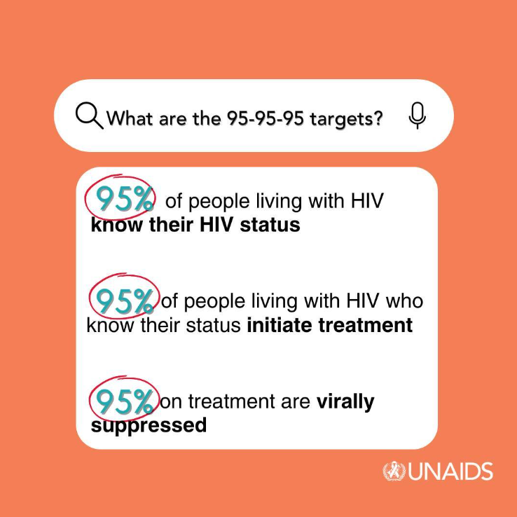

Inclusion and representation of people living with HIV is vital to Galway’s Implementation Plan. People living with HIV were contacted via the HIV support service at Sexual Health West. Sexual Health West hosted clients for a focus group discussion ahead of the annual World AIDS Day Candlelight Concert.
We aim to publish the Fast Track Cities Galway Implementation Plan 2025-2028 in 2025.

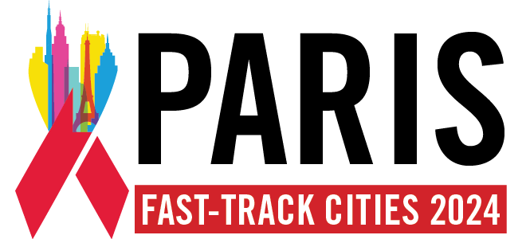
Fast Track Cities Conference – Paris

Achievements
Education Sessions Delivered 234
Attendees 4,820
Number of new HIV clients 11
Helpline / Information calls / Condom requests 2,100
Condoms distributed 20,000+
Website Views 10,000
The figures for 2024 indicate continued new referrals of HIV Positive clients and the essential need for continued support to new and existing clients. The demand for help & information continues, including condom requests through our links with the HSE National Condom Distribution Service.
In response to the rising numbers of new diagnoses of HIV, Sexual Health West became a partner of the HSE SH:24 Home Testing Service
The sexual health education team were able to further develop their programmes to groups in schools and across the community once again. We continue to offer links to the creative and exciting new virtual / on line resources – these can be found on the WISER Website (West of Ireland Sexuality Education Resource) www.bewiser.ie.
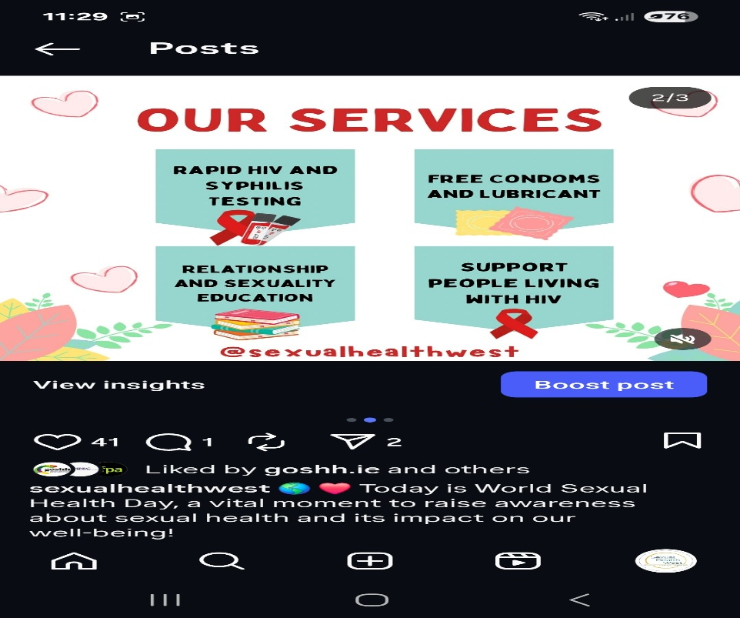
In summary, with an increase in new referrals of people newly diagnosed with HIV, the demand for HIV support services continues to grow. The WISER Sexual Health Education and Prevention programmes continue to grow and are essential in raising awareness amongst young people and other groups considered to be at risk.
Partnerships & Networking
Sexual Health West fully embraces partnership working and the importance of networking locally, regionally & nationally. We thank the following partners throughout 2024 for their support:
University Hospital Galway Infectious Disease Clinic
Irish Sexual Health & HIV Network
HSE Health Promotion
HSE Sexual Health & Crisis Pregnancy Programme
HSE Sexualwellbeing.ie
Fast Track Cities
SH:24
Galway LGBT+ Inter Agency Forum
Amach!LGBT+
Western Region Drugs & Alcohol Task Force
UNIVERSITY OF GALWAY Dept of Health Promotion, Dept of Psychology, Student Union, Student Welfare, GigSoc
USI (Union of Students in Ireland)
ATU Student Welfare Team, Student Union
The SVP
Sexual Health Centre Cork
GOSSH Limerick
HIV Ireland Dublin
Foroige
Youth Work Ireland
Rape Crisis Centre / Women’s Refuge
National Learning Network
National & Second level Schools
PLC Colleges
Third Level Colleges
Youthreach Centres
GRETB
Family Resource Centres
Galway Rural Development
Healthy Ireland
Healthy Galway
Community Centres, Groups & Organisations
Direct Provision Centres

Governance Code & Management
We fully comply with the Governance Code for community, voluntary and charitable organisations in Ireland. We confirm that a review of our organisation’s compliance with the principles in the Code has been completed based on an assessment of our organisational practice in line with the recommended actions for each principle.
• Principle 1 Leading our organisation
• Principle 2: Exercising control over our organisation
• Principle 3: Being transparent and accountable
• Principle 4: Working effectively
• Principle 5: Behaving with integrity
We confirm that our organisation is committed to the standards outlined in these principles.
We commit to reviewing our organisational practice in line with the recommended actions for each principle each year following our initial review.
In 2018, the Charities Regulator announced a new Governance code for Charities which
would facilitate the better administration, management and governance of charitable
organisations.
Principles of Charities Governance Code are:
1.Advancing Charitable Purpose
2.Behaving with Integrity
3.leading People
4.Exercising control
5.Working effectively
6. Being Accountable.

Thank you for your continuing trust and support.
The Board of Management of Sexual Health West.

Schedule 1 Employees
Role | Name | Qualification
CEO / Support Service Co-ordinator | Joe McDonagh | Graduate Diploma - Careers Guidance, University of Kent  Diploma - Connexions Personal Adviser, Manchester University  Post Graduate Diploma - Family Support Studies, NUI Galway  M.A in Family Support Studies, NUI Galway
Sexual Health Education Co-ordinator  Sexual Health Educators | Lorraine O’ Connell  Denise McAlister  John Halloran  Saoirse Browne  Ciara Mulgrew | M.A Sexuality Studies, DCU Dublin  B.A in Psychology, Sociology and Political Sciences, NUI Galway  Post Graduate Diploma in Health Promotion, NUI Galway  FPSHP  BSc. Psychology, University of Ulster  PGCE, Liverpool John Moore University  Graduate Certificate in Sexuality & Sexual Health, DCU  FPSHP  BSc. Psychology, University of Sterling  MSc. Psychological Research methods specializing in Child Development, University of Sterling  FPSHP  Bachelor Degree of Social Sciences  FPSHP  Master of Arts (Health Promotion)  Bachelor of Nursing Science (Psychiatric)
Project Manager – Galway Fast Track Cities | Hope Turner | Bachelor of Science in Health Promotion and Behaviour  Master of Public Health | International Health Concentration
Education Co-ordinator Drugs & Alcohol | Neil Wilson | B.A. in Theology, Durham University  P.G.C.E. Cambridge University  Diploma in Drugs & Alcohol Studies NUI Limerick
Office Co –ordinator  Admin Support | Josephine Mohan  Kieran Browne | Secretarial Qualification in Administration and Finance  ECDL

Sexual Health West would like to wish Kieran Browne well in his retirement after 25 years of service to the organisation – thank you Kieran.
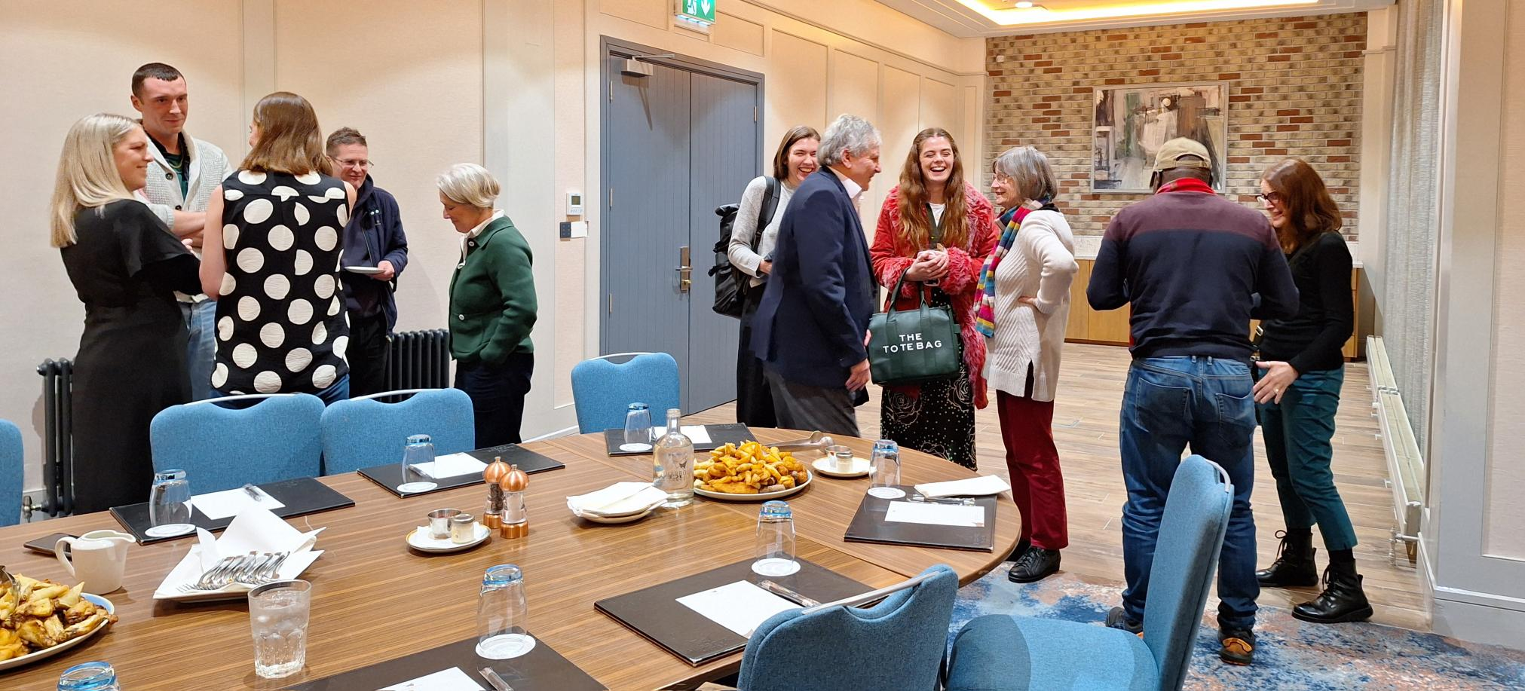
SHW Team meet the Board
Schedule 2 Board Members
Name | Workplace | Occupation
Patrick Towers | Currently on Special Projects | Chair of Board  Former Rector St Nicholas Church
Dr Claire Connolly | Dept of Health Promotion, NUIG | Company Secretary of the board of Sexual Health West  Lecturer in Health Promotion  Recently retired
Maria Molloy | University Hospital Galway | Surveillance Scientist, National HCAI/AMR Implementation team
Dr Andrea Holmes | University Hospital Galway  University of Galway | Consultant in Infectious Diseases & Genitourinary Medicine  Medical Director of Galway Sexual Assault Treatment Unit
Suzanne McKane | The BRIDGE Project, Galway City Partnership | Project Coordinator
Des Tomlinson | Irish Football Association | Intercultural Football National Coordinator
Joseph Nyirenda | International Organization for Migration | Field Coordinator
Dr Hayley Mulligan | Children’s Rights Alliance | Online Safety Legal Officer

Acknowledgements
Sexual Health West would like to express our sincere thanks to all those who have worked with us and supported us during 2024:

- To our principal funder, the Health Service Executive CHO2, the HSE Sexual Health & Crisis Pregnancy Programme and also to the Western Regional Drugs & Alcohol Task Force.
- We would like to thank Michael Keady and Thelma Birrane from HSE CHO2, and also Orla McGowan, Rachael Metrusty, Caroline Hurley, Trish Wallace and the team in the Sexual Wellbeing Programme for their ongoing support.
- To our many sponsors and donors, without whose kindness and generosity many of the programmes we undertook could not have happened, in particular to GSK, Gilead, Galway City Council & Galway County Council, LCDC.
- We would particularly like to thank the staff at the Infectious Disease Clinic at UCHG with whom we share a special working relationship.
- We acknowledge the ongoing partnership with numerous departments within University of Galway.
- We appreciate the support and shared knowledge & advice we get through partnerships with GOSHH in Limerick, The Sexual Health Centre in Cork and HIV Ireland in Dublin.
- A special thanks to the board of management of Sexual Health West.
- And last, but by no means least, to the excellent staff team at Sexual Health West and to all of our volunteers.

Sexual Health West - Continuing the essential work of supporting people living with HIV

Sincere thanks to our core funder:
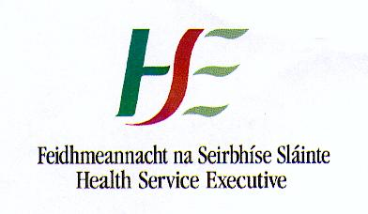
Thanks also to all other funders and supporters:
